Creational Design Pattern

Singleton Design

Aim:
The aim is to ensure that a class has only one instance globally accessible, facilitating efficient resource management and providing a centralized point for accessing and controlling shared state within the application.

Description:
The provided Java code implements the Singleton design pattern, ensuring that only one instance of the `Singleton` class exists. The class contains a private static instance and a private constructor to prevent external instantiation. Access to the singleton instance is provided through a static method `getInstance()`. The `TestClass` demonstrates obtaining and modifying singleton instances, showcasing the pattern's ability to maintain a single global point of access to shared resources. This design enhances resource management and facilitates centralized control of global state within the application. Through thread-safe instantiation and efficient memory usage, the Singleton pattern promotes efficient and organized software design.

Code:

1. Singleton.java

package design;

public class Singleton {
private static Singleton soleInst=new Singleton();
public int i;
private Singleton() {
System.out.println("Created");
}

public static Singleton getInstance() {
return soleInst;
}

public int getI() {
return i;
}

public static void getSoleInstance(Singleton soleInst) {
Singleton.soleInst = soleInst;
}
public void setI(int i) {
this.i = i;
}

}

2. TestClass.java

package design;

public class TestClass {
public static void main(String[] args) {
Singleton s1 = Singleton.getInstance();
Singleton s2 = Singleton.getInstance();
s1.setI(5);
s2.setI(10);
System.out.println(s1.getI());
s2.i = s1.i + s2.i;
System.out.println(s2.getI());
print("S1",s1);
print("S2",s2);
}
static void print(String name, Singleton obj) {
System.out.println(String.format("Object: %s, Hashcode: %d", name, obj.hashCode()));
}
}

Output:


Class Diagram:
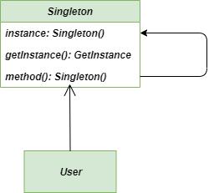

Aim:
The aim is to ensure that a class has only one instance globally accessible, facilitating efficient resource management and providing a centralized point for accessing and controlling shared state within the application.

Description:
This Java code implements a server using the Singleton design pattern. It ensures that only one instance of the server exists throughout the application, with lazy initialization for efficiency. The `getInstance()` method provides access to the singleton instance, while a private constructor prevents direct instantiation. The `Server` class includes start and stop methods for server functionality. This design facilitates centralized control and resource management in server-based applications, ensuring consistency and efficient resource utilization.

Code:

1. Server.java
public class Server {
// Private static instance of the Server class
private static Server instance;

// Private constructor to prevent instantiation from outside
private Server() {
// Initialization code here
}

// Static method to get the instance of the Server class
public static Server getInstance() {
// Lazy initialization: Create instance if null
if (instance == null) {
synchronized (Server.class) {
if (instance == null) {
instance = new Server();
}
}
}
return instance;
}

// Other methods of the Server class can be added here

public void start() {
System.out.println("Server started.");
}

public void stop() {
System.out.println("Server stopped.");
}

public static void main(String[] args) {
// Get the instance of the server
Server server = Server.getInstance();

// Use the server
server.start();
// ... do something with the server

// Stop the server
server.stop();
}
}

Output:

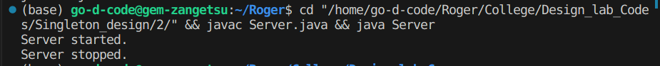
Class Diagram:
